**Model Development Phase Template**

|  |  |
| --- | --- |
| Date | 19 july 2024 |
| Team ID | SWTID1720084639 |
| Project Title | Beneath the Waves: Unraveling Coral Mysteries through Deep Learning |
| Maximum Marks | 10 Marks |

**Initial Model Training Code, Model Validation and Evaluation Report**

The initial model training code will be showcased in the future through a screenshot. The model validation and evaluation report will include a summary and training and validation performance metrics for multiple models, presented through respective screenshots.

**Initial Model Training Code (5 marks):**

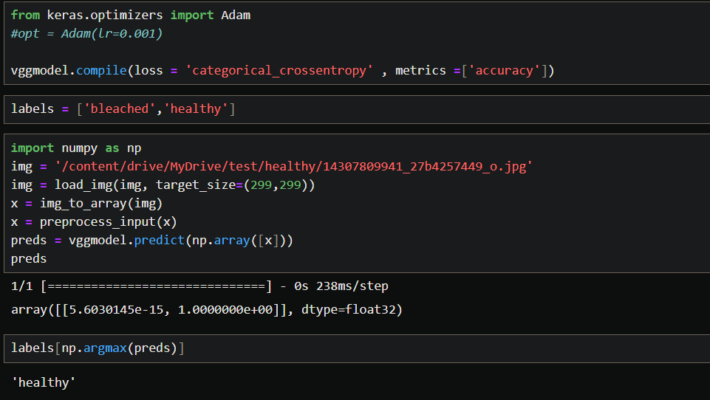

**Model Validation and Evaluation Report (5 marks):**

|  |  |  |
| --- | --- | --- |
| **Model** | **Summary** | **Training and Validation Performance Metrics** |
| **VGG16** |  |  |
| **RESNET** |  |  |
| **INCEPTION** |  |  |
| **DENSENET** |  |  |
| **XCEPTION** |  |  |